**CCNA – 200 – 301**

(Lab # 1)

Basic Device Configuration (Switch)

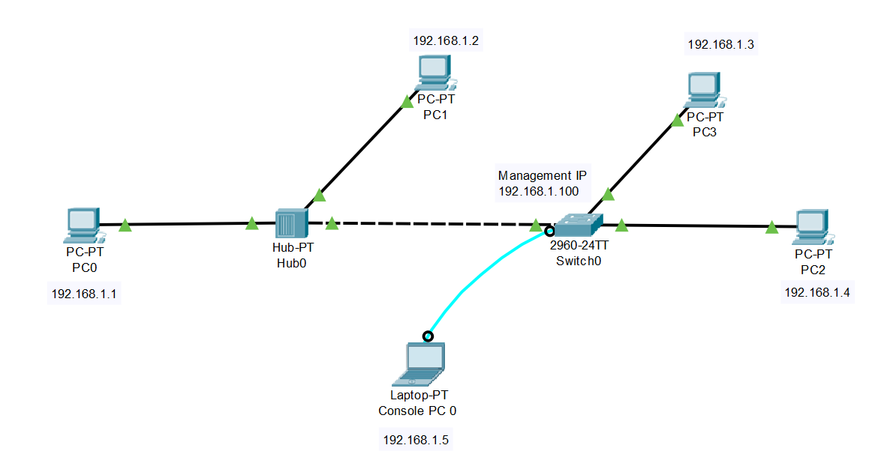

**Configuring hostname of Switch0**

Switch>enable

Switch#configure terminal

Switch(config)#hostname AXIOM

AXIOM(config)#exit

AXIOM#

**Setting up logon banner of Switch0**

AXIOM>enable

AXIOM#configure terminal

AXIOM(config)#banner motd %

Enter TEXT message. End with the character '%'.

**********************************************

AXIOM COMPUTER EDUCATION

**********************************************

%

AXIOM(config)#exit

AXIOM#

**Configuring console password to switch**

AXIOM>enable

AXIOM#configure terminal

AXIOM(config)#line console 0

AXIOM(config-line)#password 12345

AXIOM(config-line)#login

AXIOM(config-line)#exit

AXIOM(config)#exit

AXIOM#

**Configuring vty password to switch**

AXIOM>enable

AXIOM#configure terminal

AXIOM(config)#line console 0

AXIOM(config-line)#password 12345

AXIOM(config-line)#login

AXIOM(config-line)#exit

AXIOM(config)#exit

AXIOM#

**Configuring enable (privileged mode) password to switch**

AXIOM>enable

AXIOM#configure terminal

AXIOM(config)#enable password 12345

AXIOM(config)#exit

AXIOM#

**Configuring enable (privileged mode) secret to switch**

AXIOM>enable

AXIOM#configure terminal

AXIOM(config)#enable secret 123456

AXIOM(config)#exit

AXIOM#

**Encrypt the enable and console passwords**

AXIOM>enable

AXIOM#configure terminal

AXIOM(config)#service password-encryption

AXIOM(config)#exit

AXIOM#

**Save and verify configuration file to NVRAM**

AXIOM>enable

AXIOM#copy running-config startup-config

AXIOM#

**Erase NVRAM/Start-up configuration**

AXIOM>enable

AXIOM#erase startup-config

Or

AXIOM>enable

AXIOM#write erase

**Disabling login on vty**

If you want to allow only one virtual connection (1 vty) i.e. telnetting or SSH, while making other 15 vty lines disabled, you can use the configuration below. But if we provide password to disabled lines, they will be enabled and secured.

AXIOM>enable

AXIOM#configure terminal

AXIOM(config)#line vty 0

AXIOM(config-line)#password 12345

AXIOM(config-line)#login

AXIOM(config-line)#exit

AXIOM(config)#line vty 1 15

AXIOM(config-line)#no password

AXIOM(config-line)#login

AXIOM(config-line)#exit

AXIOM(config)#exit

AXIOM#

**Setting management IP to switch for telnetting/SSH**

AXIOM>enable

AXIOM#configure terminal

AXIOM(config)#interface vlan 1

AXIOM(config-if)#ip address 192.168.1.100 255.255.255.0

AXIOM(config-if)#no shutdown

AXIOM(config-if)#exit

AXIOM(config)#exit

AXIOM#

**Configuring SSH to switch**

We need to set following for configuring SSH on switch

1. Hostname
2. Domain Name
3. Secure Key
4. SSH version 2
5. Create Users
6. Allow SSH

Switch>enable

Switch#configure terminal

Switch(config)#hostname AXIOM

AXIOM(config)#ip domain-name education.com.pk

AXIOM(config)#crypto key generate rsa

How many bits in the modulus [512]: 1024

AXIOM(config)#ip ssh version 2

AXIOM(config)#username gulraiz password 12345

AXIOM(config)#username husnain password 12345

AXIOM(config)#line vty 0 15

AXIOM(config-line)#login local

AXIOM(config-line)#transport input ssh

AXIOM(config-line)#exit

AXIOM(config)#exit

AXIOM#

**Other useful show commands**

Switch>enable

AXIOM#show mac-address-table dynamic

AXIOM#show running-config

AXIOM#show startup-config

AXIOM#show interfaces status

AXIOM#show ip interface brief